The 2025 Guide
to
Getting Married
at
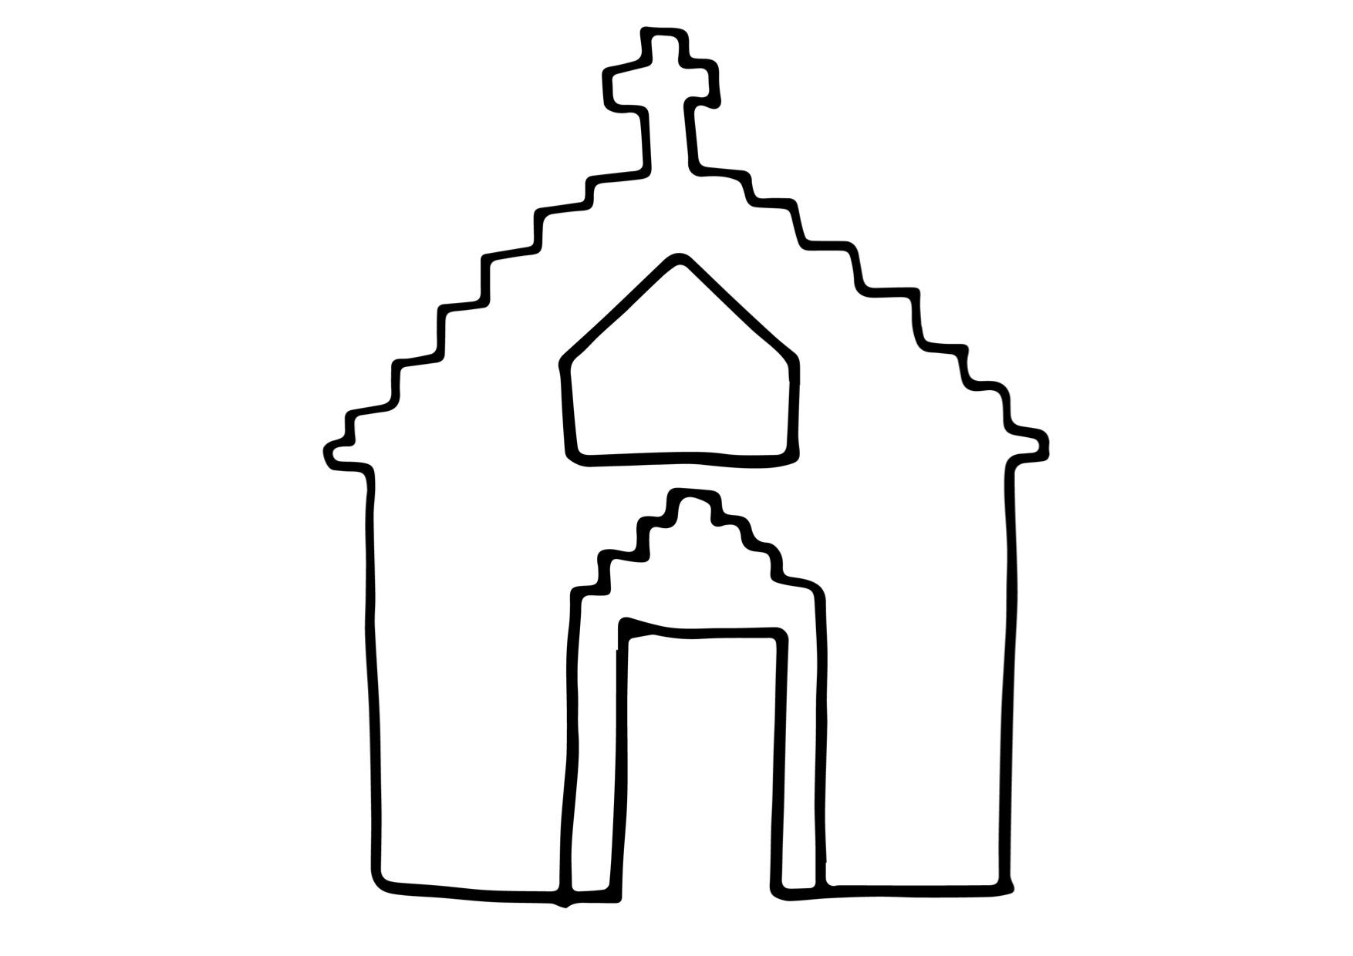
St James’ Church, Alderholt

Useful contacts:
The Vicar Rev Simon Woodley
01425 839068
stjamesvicar@yahoo.com

The Parish Administrator Holly Botto
07805 979827
stjameschurchalderholt@gmail.com

The Organist Stephen Rothwell
01425 655210
stephen@custom-internet.co.uk

The Flowers Carol Edwards
‭01425 654416‬
edwards.ac76@gmail.com

why not try: www.yourchurchwedding.org

This is going to be a really exciting year for you, and we want to make sure that it all goes smoothly. Now that you've made the choice of who you want to spend the rest of your life with, we want to help you to understand and make the best choices for the day itself.

In this booklet you will find information about:

The Venue
Banns
Music
Vows
Readings
Rehearsal
Orders of service
Photos and videos
Flowers
Ushers
Confetti
Costs

The Venue
St James is our village church, and is a beautiful and holy place, in an idyllic setting. It is open every day of the year for visitors and prayer, so do pop in if you haven’t seen it before. It is primarily the home of the worshipping congregation, and all their events and festivals like Christmas and Easter and so on. It's worth thinking about dates and checking for possible clashes at an early stage.

It seats around 130 people, and has an organ and space for other musicians if you wish it. Unfortunately it doesn’t have a peal of bells or a choir. There is parking for 20 cars next to the church, and a further 60 cars in the overflow car park at the other end of the churchyard.
Banns
The Banns are the legal way of informing the world that you are getting married, and asking if there is any objection. They need to be ‘called’ in the church you are getting married in, and in the parish where you live, and in any other church where you are on the electoral roll. This means it can need to be done in three or four places!
We will arrange for this at St James, but it's up to you to sort it for where you live and/or worship. If you put your postcode into achurchnearyou.com you will find the details of how to get in touch with them. The Vicar there will issue a certificate saying that the Banns have been ‘called’, and that no-one has objected.

Banns are usually ‘called’ on the first, second and third Sundays of the month, at the 10:30 morning service. We usually do them 3 months before your wedding month - so we ‘call’ them in April for a June wedding, or June for an August one and so on. We’ll send you a letter to remind you, and it’s really good for you to be there at least once to hear them, especially the first week, just to check that all the details are correct.

If they are not ‘called’ when you expect them, or if there is anything wrong with the details, please tell the minister leading the service immediately after the service, and they will put matters right as soon as possible.

Music
Most people like to sing a hymn or two, so please include the price of the organist in your wedding. You’re welcome to provide your own organist, but you will still have to pay a fee for the organ.
Many people now play the other music, for entry of the bride, signing the registers and the dismissal, through their phone. We can also play CD’s, but phone is better. Please choose someone responsible to press play and stop the music at the right time!

As well as 2 hymns or worship songs during the service you need to choose music for
- the entry of the bride
- the final procession
- time during signing of the registers.

Wedding Hymns and Processional Music
There are a number of websites where you can listen to these to help you choose, including:
www.2-in-2-1.co.uk
www.confetti.co.uk
www.weddingguide.co.uk

Some suggestions for music at the bride’s entrance
Trumpet Voluntary - Jeremiah Clark
Trumpet Tune - Purcell
Trumpet Tune - Charpentier
Wedding March - Wagner
Hornpipe ("water music" - Handel)
Minuet ("Royal Fireworks" - Handel)

Some possible Hymns for the service:

For the beauty of the earth
Father, hear the prayer we offer
Dear Lord and Father of mankind
All things Bright and Beautiful
Love divine all loves excelling
Come down, O Love divine
Praise my soul, the King of heaven
Fill thou my life, O Lord my God
Now thank we all our God
Lead us heavenly Father, lead us
Jesus, good above all other
Lord Jesus Christ, you have come to us
Lord of all hopefulness
Give me joy in my heart

Some suggestions for music for the final procession
Wedding March - Mendelssohn
Grand March from Aida - Verdi
March from Occ. Oratorio - Handel
Minuet ("Royal Fireworks") Handel
(All Trumpet Tunes from "entrance" section are also suitable.)

Vows
This is the heart of the service, the point of the day, so you might like to spend time together talking through what this means, you can even practice saying them to each other!

The minister says to the bridegroom
“N, will you take N to be your wife? Will you love her, comfort her, honour and protect her, and, forsaking all others, be faithful to her as long as you both shall live? “

He answers:
“I will..”

The minister says to the bride
“N, will you take N to be your husband? Will you love him, comfort him, honour and protect him, and, forsaking all others, be faithful to him as long as you both shall live? “

She answers:
“I will.”

The minister says to the congregation
“Will you, the families and friends of N and N, support and uphold them in their marriage now and in the years to come? “

The congregation answers:
“We will. “
A hymn may be sung.

The couple stand before the minister.

The minister introduces the vows in these or similar words
“N and N, I now invite you to join hands and make your vows, in the presence of God and his people. “

The bride and bridegroom face each other.
The bridegroom takes the bride's right hand in his.

“I, N,
take you, N,
to be my wife,
to have and to hold
from this day forward;
for better, for worse,
for richer, for poorer,
in sickness and in health,
to love and to cherish,
till death us do part.,
according to God's holy law.
In the presence of God I make this vow. “

They loose hands. The bride takes the bridegroom's right hand in hers, and says
“I, N,
take you, N,
to be my husband,
to have and to hold
from this day forward;
for better, for worse,
for richer, for poorer,
in sickness and in health,
to love and to cherish,
till death us do part;
according to God's holy law.
In the presence of God I make this vow. “

They loose hands.

The minister receives the ring(s), and says this prayer:
“Heavenly Father, by your blessing let these rings be to N and N a symbol of unending love and faithfulness, to remind them of the vow and covenant which they have made this day through Jesus Christ our Lord. “ Amen.”

The bridegroom places the ring on the fourth finger of the bride's left hand and, holding it there, says

“N, I give you this ring
as a sign of our marriage.
With my body I honour you,
all that I am I give to you,
and all that I have I share with you,
within the love of God,
Father, Son and Holy Spirit.”

If rings are exchanged, they loose hands and the bride places a ring on the fourth finger of the bridegroom's left hand and, holding it there, says

“N, I give you this ring
as a sign of our marriage.
With my body I honour you,
all that I am I give to you,
and all that I have I share with you,
within the love of God,
Father, Son and Holy Spirit.”

Readings
You can choose any part of the Bible to be read at your wedding, but here are two of the most popular:

1 Corinthians 13
If I speak in the tongues of mortals and of angels, but do not have love, I am a noisy gong or a clanging cymbal. And if I have prophetic powers, and understand all mysteries and all knowledge, and if I have all faith, so as to remove mountains, but do not have love, I am nothing. If I give away all my possessions, and if I hand over my body so that I may boast, but do not have love, I gain nothing.

Love is patient; love is kind; love is not envious or boastful or arrogant or rude. It does not insist on its own way; it is not irritable or resentful; it does not rejoice in wrongdoing, but rejoices in the truth. It bears all things, believes all things, hopes all things, endures all things. Love never ends.

Song of Solomon 2.10-13; 8.6,7
My beloved speaks and says to me:
'Arise, my love, my fair one,
and come away;
for now the winter is past,
the rain is over and gone.
The flowers appear on the earth;
the time of singing has come,
and the voice of the turtle dove
is heard in our land.
The fig tree puts forth its figs,
and the vines are in blossom;
they give forth fragrance.
Arise, my love, my fair one,
and come away.'
Set me as a seal upon your heart,
as a seal upon your arm;
for love is strong as death,
passion fierce as the grave.
Its flashes are flashes of fire,
a raging flame.
Many waters cannot quench love,
neither can floods drown it.
If one offered for love
all the wealth of one's house,
it would be utterly scorned.

You may also have one other reading that is not from the Bible.
Try googling - ‘readings for wedding ceremonies’, you’ll get a wide choice!

Rehearsal
This usually takes place on a weekday evening during the week before. It lasts about half an hour, and besides the Bride and Groom, the other people that need to be there are the Best Man, Bridesmaids, and whoever is giving the Bride away (if you are doing that).

Orders of Service
We provide the necessary service books, and hymn books, so a printed order of service is not strictly necessary, but it does make a pleasant memento of the occasion.

Please show the "proof" copy to the minister taking your service so that they can check it is all correct before printing the full amount.

We can produce Orders of Service for you, from £75 for 100 basic black & white copies. Please enquire for colour copy costs.

A Typical order of service might be:
Arrival of the Bride
Welcome
Hymn
The Declarations
Reading
Talk
Hymn
The Vows
The Giving of Rings
Registration of the Marriage
Prayers
The Lord's Prayer
Blessing
Departure of the Bride and Groom

Photo's and Video's
It’s great to have a record of the occasion, and we have no objection to photographers or videos: it’s your day and you should get what you want wherever possible.

Whether you are using a professional or a friend, make sure that they know exactly the shots you want - whether you want them to be standing over your shoulder as you say your vows or not, whether you want them to stop your procession going down the aisle, etc. The day is about you, not your photographer, so be firm!

If you are having a video there is a good place to put a stationary camera up in the choir, stalls and we suggest that any other handheld shots are from the congregational point of view.

Flowers
Flowers will gladly be arranged by the Church’s team of volunteers: please make contact with Carol as early as possible to discuss your requirements and what is possible!

Usher
It is helpful if you can provide 2 or 3 people to act as ushers. Their task is to make sure that everyone is seated in the right places, and has all the books and papers they need. Also to direct cars where to park, and sometimes press “play” for the music.

Confetti
We are very, very, happy for you to use confetti to celebrate your special day. Please don't use it indoors, and use paper, not metal or plastic stuff (you'd be surprised!).

The Cost of your wedding service

These Fees are subject to the Church's Central Board of Finance, and our PCC, and will go up every January.

Legal fees payable to this church
Statutory fee for a basic Church of England wedding service £544
This includes the church costs (inc. lighting and administration)

Fee for reading of banns at this church £37

Certificate of banns (if needed) £19

Plus… see below…

Extras which you may choose or decline

Verger - £40
Strongly recommended

Organist - £60
payable if you are having any music, so you may as well use him!

Flowers £200

Heating (Oct - Apr) £100

We ask that fees be paid at the latest 1 month before the wedding. If there is any difficulty in this matter, please discuss it with the minister taking your service, we have a hardship fund and we’ll be glad to help you if we can.

Please make cheques payable to “St James PCC”
or pay by BACS to: PCC ALDERHOLT
Sort code 30-97-08 Account no: 01237203

Wedding Certificates – From the 4th May 2021 a Marriage document is signed at the Wedding and then the Wedding Certificate is issued by the Local register Office after the Wedding. If you need a proof of marriage for your honeymoon, this can be arranged.
NB If a marriage licence is required, you should be advised that the licence fee replaces the banns fee above and is payable to the issuing authority, (please refer to the relevant issuing authority for the current licence fees). Couples who need to have additional banns readings at churches other than the marrying church should be advised of the statutory payment of £37 for reading the banns and £19 for the required banns certificate; a total of £56 payable to each church, other than the marrying church, which reads their banns.

